You are invited to…
Celebrate Public Education!
In observance of PUBLIC EDUCATION WEEK in Ohio,
as proclaimed by elected officials to be January 21-27, 2018,
“GO PUBLIC” with Public Education Partners…
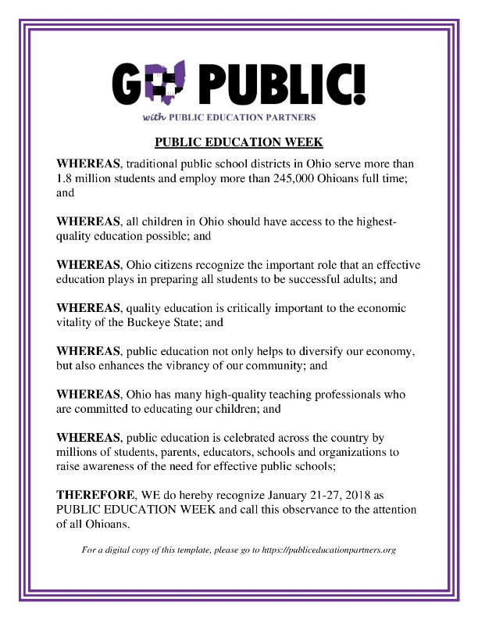
Join us as we SHINE THE LIGHT on our STUDENTS & TEACHERS!
Public Education Partners will honor teachers & students in Ohio's Public Schools. Kindergarten – High School students with their teachers will share Jazz, Poetry, Film & Video, Classroom Projects and more! Students, teachers, & administrators from Columbus, Bexley, Cincinnati, Brecksville-Broadview Heights,
Geauga Local & Logan Hocking School Districts will be recognized!
Let's CELEBRATE Ohio's Public School Districts together!

When: January 23, 2018
Time: 11:00 am – 1:00 pm
Where: The Ohio Statehouse Atrium

